**MongoDB Assignment 4**

1. Calculate Total Sales for Each Order.

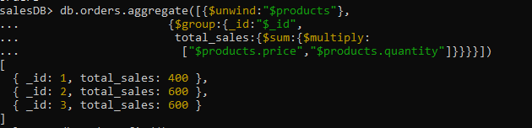

1. Calculate Average Order Value for Completed Orders.



1. Find the Maximum Quantity Sold per Product.

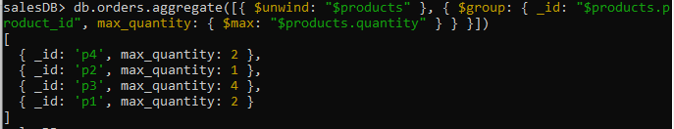

1. Find Total Number of Orders for Each Status.

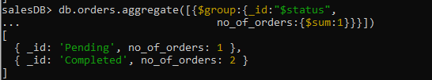

1. Calculate Total Quantity of Products Sold Across All Orders.



1. Get Minimum and Maximum Order Dates.

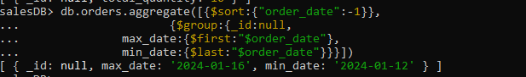

1. Find Total Sales for Each Customer.

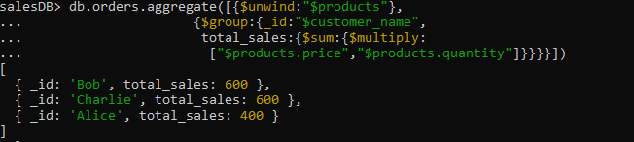

1. Calculate the Total Number of Distinct Products Sold.

